**Experiment: To perform ASK Modulation & Demodulation using Scilab.**

**Scilab Code**

**Best Way:1**

clc

clear

close

Ac=10; *// Amplitude of carrier*

fc=0.1; *// Normalized frequency of carrier signal*

Am=2; *// Amplitude of modulating signal*

fm=0.01; *// Normalized frequency of modulating signal*

j=0;

x_min=0;

step=0.01;

x_max=300;

x_axis=[x_min:step:x_max];

c_t = Ac*cos(2*%pi*fc*x_axis); *// Carrier signal*

m_t= Am*cos(2*%pi*fm*x_axis); *// Modulating signal*

b_t=(sign(m_t)+1)/2; *// Binary unipolar modulating signal*

s_t=b_t.*c_t; *// ASK signal*

subplot(4,1,1)

plot2d(x_axis,m_t,3)

xtitle('Modulating Signal','t----->','y----->')

a=gca()

a.x_location="origin"

a.y_location="origin"

subplot(4,1,2)

plot2d(x_axis,c_t,5)

xtitle('Carrier Signal','t----->','y----->')

a=gca()

a.x_location="origin"

a.y_location="origin"

subplot(4,1,3)

plot2d(x_axis,b_t,2)

xtitle('Binary polar modulating Signal','t----->','y----->')

a=gca()

a.x_location="origin"

a.y_location="origin"

subplot(4,1,4)

plot2d(x_axis,s_t,6)

xtitle('ASK Signal','t----->','y----->')

a=gca()

a.x_location="origin"

a.y_location="origin"

**…**

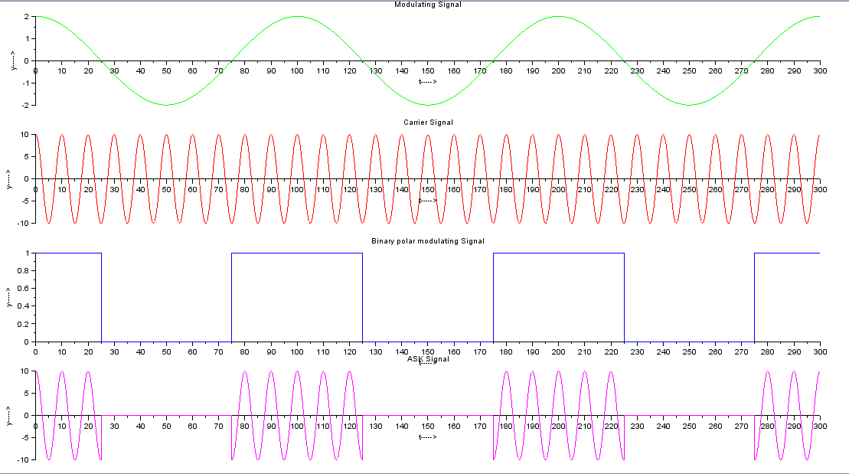

**Experiment: To perform PSK Modulation & Demodulation using Scilab.**

**PSK Scilab Code Best Way:**

clc

clear

close

Ac=10; *// Amplitude of carrier*

fc=0.1; *// Normalized frequency of carrier signal*

Am=2; *// Amplitude of modulating signal*

fm=0.01; *// Normalized frequency of modulaing signal*

j=0;

x_min=0;

step=0.01;

x_max=300;

x_axis=[x_min:step:x_max];

c_t = Ac*cos(2*%pi*fc*x_axis); *// Carrier signal*

m_t=Am*cos(2*%pi*fm*x_axis); *// Modulating signal*

b_t=sign(m_t); *// Binary polar modulating signal*

s_t=b_t.*c_t; *// PSK signal*

subplot(4,1,1)

plot2d(x_axis,m_t,3)

xtitle('Modulating Signal','t----->','y----->')

a=gca()

a.x_location="origin"

a.y_location="origin"

subplot(4,1,2)

plot2d(x_axis,c_t,5)

xtitle('Carrier Signal','t----->','y----->')

a=gca()

a.x_location="origin"

a.y_location="origin"

subplot(4,1,3)

plot2d(x_axis,b_t,2)

xtitle('Binary polar modulating Signal','t----->','y----->')

a=gca()

a.x_location="origin"

a.y_location="origin"

subplot(4,1,4)

plot2d(x_axis,s_t,6)

xtitle('PSK Signal','t----->','y----->')

a=gca()

a.x_location="origin"

a.y_location="origin"

**…**

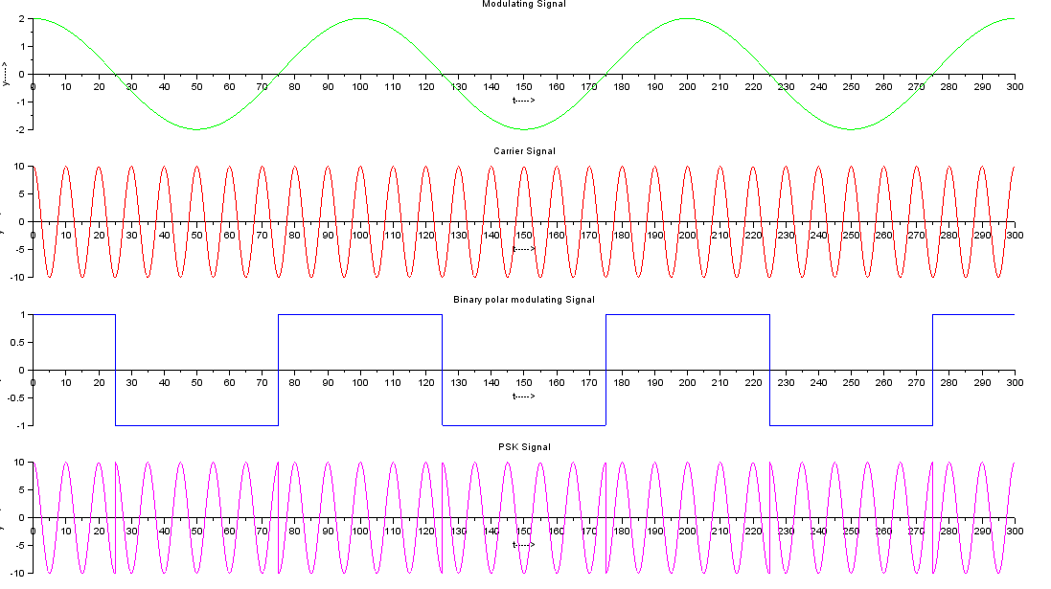

**…………**

**Experiment: To perform Signal Sampling and Reconstruction Techniques using Scilab.**

**Scilab Code**

clc;close;clear;

t=-10:.001:10;

fm=1;

y1=sin(2*%pi*fm*t);

figure(1)

subplot(2,2,1)

plot2d(t,y1);

xtitle('Message Signal','t--->','');

fs=1.5;

Ts=1/fs;

n=-100:100;

y2=sin(2*%pi*fm*n*Ts);

*//figure(2)*

subplot(2,2,2)

plot2d3(n,y2);

xtitle('Sampled signal','n (nTs)--->','');

h=sinc(n/Ts);

t1=n*Ts;

L1=length(h)

*//figure(3)*

subplot(2,2,3)

plot2d(Ts:Ts:L1*Ts,h);

xtitle('Impulse response of LPF','t--->','');

y3=conv(y2,h)

*//t1=-10:.01:10;*

*//plot2d(t1,sinc(t1))*

*//figure(4)*

L=length(y3);

subplot(2,2,4)

plot2d(Ts:Ts:L*Ts,y3);

xtitle('Recontructed','t--->','');

fm=1Hz, fs= 10 sample/sec , fs > 2fm

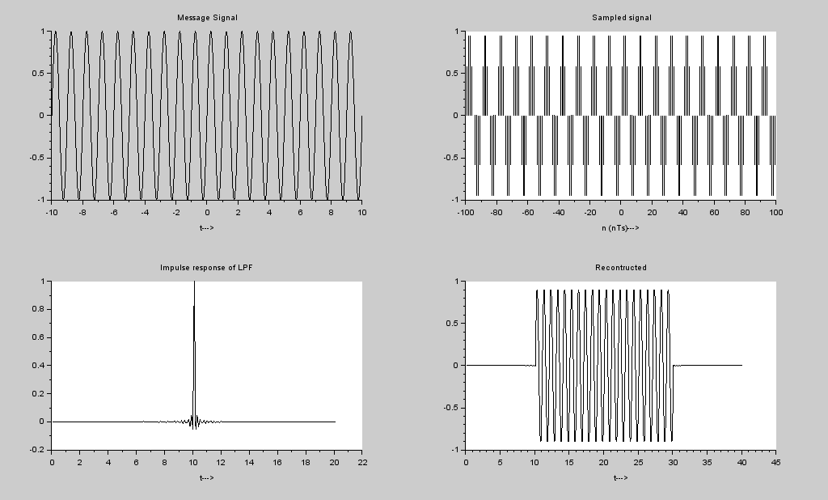

fm=1Hz, fs = 1.5 sample/sec , fs < 2fm

